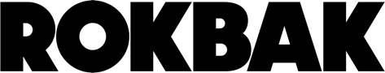
PRESS RELEASE
February 2026

Rokbak appoints Trevotech as dealer partner in Angola

With Angola entering a new phase of infrastructure and mining development, Rokbak has partnered with Trevotech to deliver robust articulated haulers, backed by strong local sales and aftermarket support.

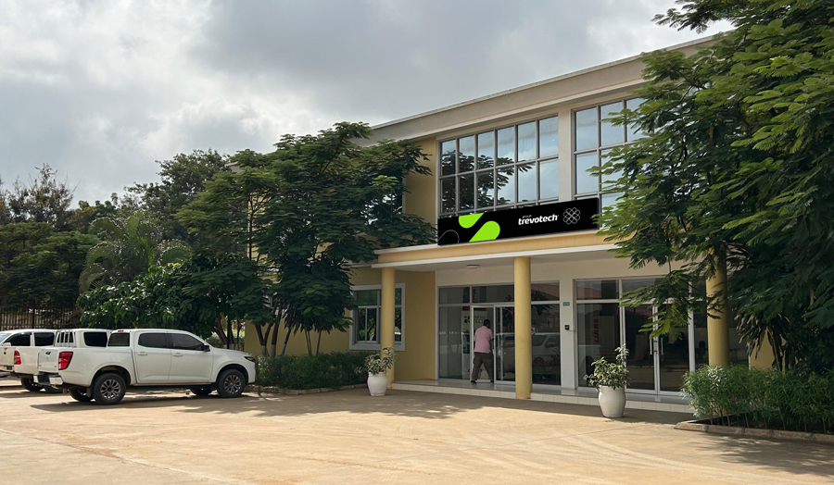

Trevotech is the new authorised Rokbak dealer in Angola.

Rokbak has appointed Trevotech as its new authorised dealer in Angola, strengthening the articulated hauler manufacturer’s presence in another African market that’s experiencing renewed growth in infrastructure, mining and large-scale earthmoving projects.

Angola is entering a new phase of national development, with increasing demand for robust, high-performance equipment capable of operating in extreme conditions. Trevotech identified the need for a robust and reliable articulated hauler brand with proven engineering, strong heritage and a long-term commitment to the market, all qualities embodied by Rokbak trucks.

“Angola is a demanding market for ADTs,” says António Pereira, Managing Director of Trevotech. “Equipment here must operate in high temperatures, dusty, remote locations and often under challenging maintenance conditions.

“Rokbak articulated haulers are designed to be simple to use and maintain, exceptionally robust and built for high uptime, which makes them ideally suited to our operating environment.”

As part of the Volvo Group, Rokbak brings proven, global engineering standards, reliability and practical truck design, while Trevotech contributes strong local knowledge, established infrastructure and a long-term strategy focused on supporting Angola’s development sectors. Together, the companies will deliver not just trucks, but a complete ecosystem of sales, service and support.

Two types of hauler. One tough environment.

Angola represents a strong market for both the Rokbak RA30 and RA40 articulated haulers. Demand for articulated haulers in Angola is increasing alongside road construction, mining exploration, quarry expansion and large agricultural projects.

The RA30 is well suited to general construction, mid-size quarries and agricultural earthworks, while the higher-payload RA40 is ideal for large infrastructure and mining applications where maximising tonnes moved per cycle is critical to lowering cost per tonne.

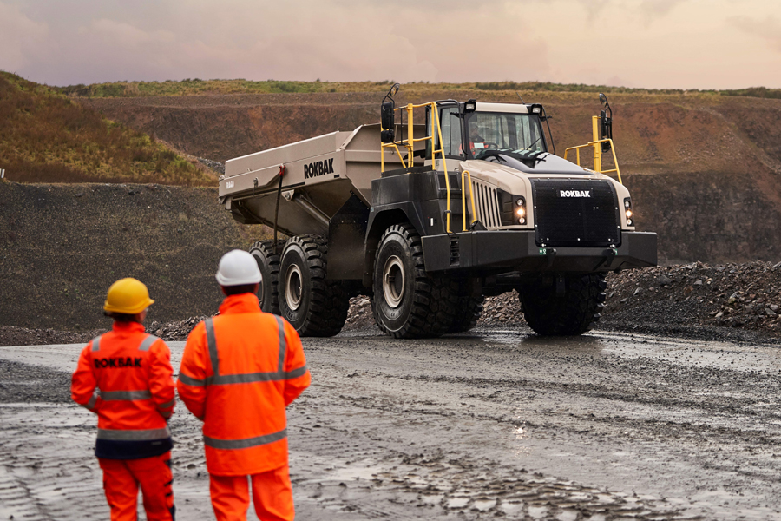

The Rokbak RA40 is ideal for large infrastructure and mining applications.

“Rokbak’s range sits exactly in the payload categories most used in Angola,” explains António. “The trucks deliver strong traction, stable performance on rough terrain and reliable operation in high ambient temperatures, all essential for long working cycles in harsh ground conditions.”

Compared to other articulated dump trucks on the market, Rokbak haulers are recognised for their durability, ease of maintenance and strong total cost of ownership. For contractors and fleet owners, these attributes translate directly into fuel efficiency, reduced downtime, operator comfort and long-term value.

Support that doesn’t stop at the sale

A key pillar of the partnership is comprehensive aftermarket support. Customers will benefit from full-lifecycle services, including pre-sales consultation, operator and technician training, preventive maintenance programmes and reliable parts supply.

Trevotech’s established presence across Angola, with headquarters in Luanda and a growing regional network, enables fast response times and local service support. Maintaining strong parts availability is a priority, with critical components held locally and logistics structured to maximise machine uptime.

“Our objective is to maximise machine uptime, performance and operational life for every customer,” says António. “Training, preventive maintenance and rapid parts availability are essential to achieving that.”

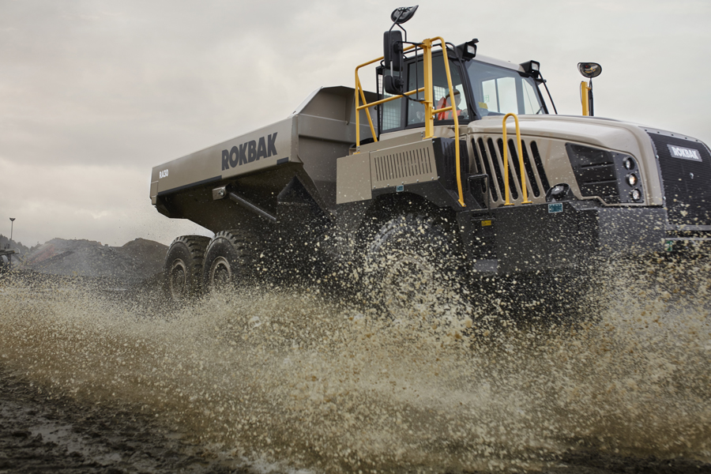

The Rokbak RA30 is robust, reliable and efficient.

Strong outlook in Angola

Looking ahead, both companies see the partnership developing into a long-term strategic presence for Rokbak in Angola, with increasing fleet penetration across construction, mining, quarrying and agricultural projects as infrastructure investment continues.

As demand for articulated haulers grows, Trevotech and Rokbak are positioned to deliver reliable equipment and professional support to meet the country’s evolving needs. Promotion of the Rokbak range will include on-site demonstrations, direct engagement with contractors, participation in industry networks and integration into major project bids. Close cooperation with the Rokbak team has already played a key role in establishing the partnership, demonstrating a strong commitment to the Angolan market.

“Trevotech has the capability and ambition we look for in a Rokbak partner,” says Paul Culliford, Rokbak Regional Sales Manager EMEA. “Their local presence, expertise and work ethic, combined with our articulated haulers, should give current and prospective customers confidence that they’re investing in equipment backed for the long term.”

“We’re excited to see this partnership develop and support customers in Angola.”

Visit the Rokbak website or the Trevotech website to learn more.

Ends.

CONTACT:
Jacqueline Reid Charlie Williams
Rokbak SE10
Tel: int +44 (0) 7736117456 Tel: int +44 (0) 7891056421
Email: press@rokbak.com Email: charlie.williams@se10.com

ABOUT ROKBAK
Rokbak is a manufacturer of off-highway articulated haulers that are used in mining, quarrying, and construction applications around the world. A member of the Volvo Group and headquartered in Motherwell, Scotland, UK, Rokbak has two models of articulated haulers, with payloads ranging from 28 to 38 tonnes (30.9 to 41.9 US tons).

rokbak.com

