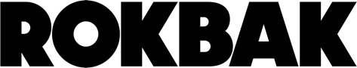
PRESS RELEASE
January 2026

Rokbak recognises Dealer of the Year and partnerships at AED

Positive discussions, strong dealer connections and a clear sense of momentum defined Rokbak’s return to the AED Summit, where the company named its Dealer of the Year for 2025.

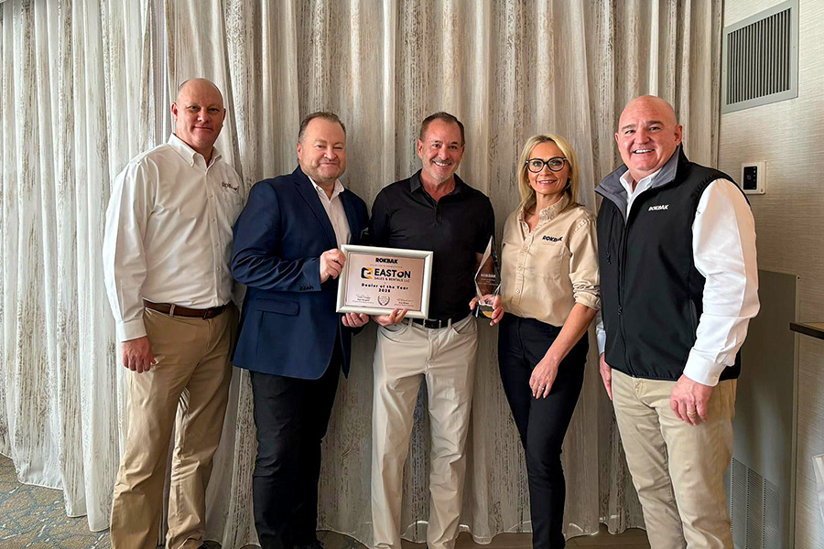

Easton Sales & Rentals was named Rokbak's Dealer of the Year for 2025 thanks to its outstanding performance.

The presence of Rokbak at the Associated Equipment Distributors (AED) Summit 2026 in the US helped outline a strong strategy for the new year and brought the RA30 and RA40 trucks centre stage in the world’s biggest articulated dump truck (ADT) market.

At the January gathering in Texas, the Scottish hauler manufacturer placed a strong focus on celebrating the partnerships that continue to drive success for the brand across North America. Part of that was recognising Houston-based heavy equipment specialist Easton Sales & Rentals, as the company’s Dealer of the Year for 2025.

“The award highlights Easton’s outstanding sales performance on both truck and factory-approved parts, strong alignment with the Rokbak brand and unwavering commitment to customer support,” says Robert Franklin, Rokbak director of sales – Americas.

“Our dealers are central to everything we do. Easton exemplifies what a strong, engaged Rokbak partner looks like, and it was a real pleasure to recognise their achievements during AED 2026.”

Confidence in Rokbak products, people and partnerships

Conversations across the three-day event, which took place between January 19th – 21st at the Hilton Anatole Dallas, focused on market developments, dealer feedback, customer insights and collaborative strategies to support continued growth.

“AED always delivers a great mix of meaningful conversations and positive energy,” says Robert. “It’s where we reconnect with our dealers, share ideas and build on what we’ve achieved together. Dealer feedback was excellent. Customers are pleased with the performance of the trucks and dealers are happy with the support they get from the Rokbak team. AED 2026 has reaffirmed real confidence in our products, our people and our partnerships.”

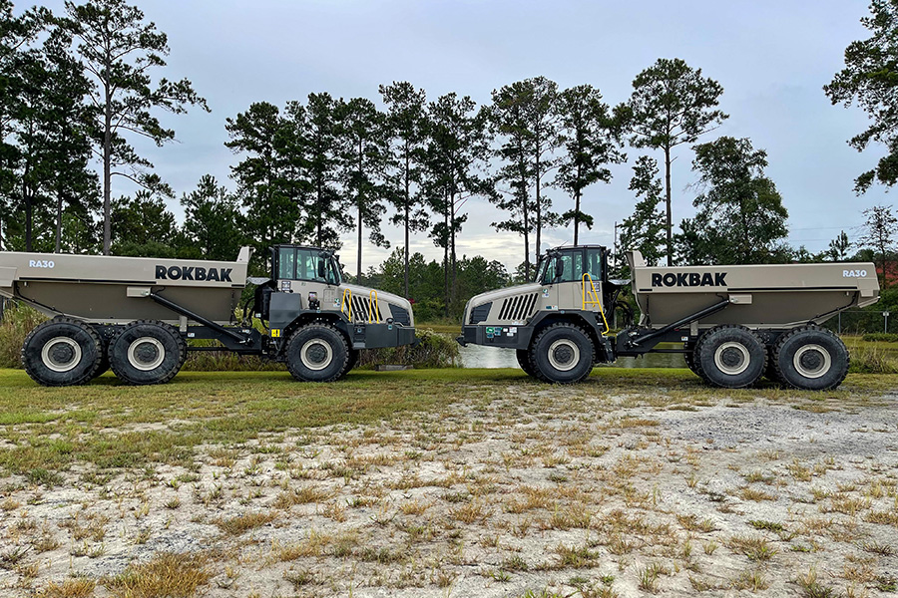

The first pair of Rokbak RA30 haulers were sent to heavy equipment specialist Easton Sales & Rentals in 2021.

Success for Easton Sales & Rentals

In September 2021, the first pair of RA30 ADTs were dispatched from the Rokbak factory in Motherwell, Scotland, and sent to Easton, marking the beginning of the Rokbak journey into the public arena.

“We knew we were onto a good thing from the very beginning,” says Jeff Udelson, managing principal of Easton Sales & Rentals. “Rokbak haulers have proven themselves to be productive, competitive trucks in the USA. Being recognised as Rokbak Dealer of the Year is something we’re all extremely proud of. Achieving and exceeding our goals has been a real group effort.”

As one of Rokbak’s earliest partners in North America, Easton has played an important role in the brand’s continued growth across the region. Its focus on customer relationships, aftersales support and long-term collaboration exemplifies the standards Rokbak values across its dealer network.

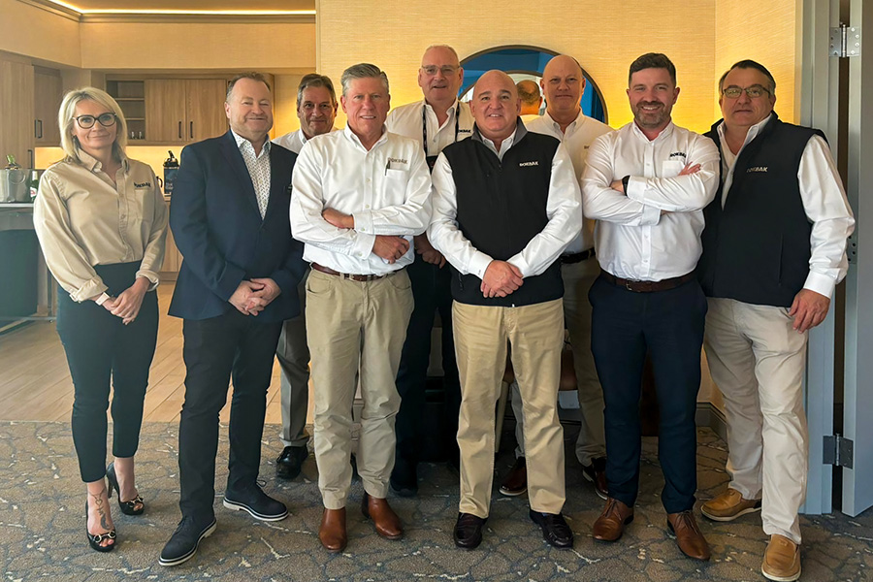

The Rokbak senior leadership and sales team met with dealer partners at AED to discuss customer feedback, market insights and future plans.

Looking ahead with confidence

With demand remaining strong across the construction, quarrying and infrastructure sectors, Rokbak continues to invest in its dealer relationships and customer support capabilities. AED 2026 provided a platform not only to reflect on achievements, but also to align on priorities for the year ahead.

As Rokbak looks beyond AED 2026, the focus is clear: continue to work closely with a strong dealer network to deliver dependable machines, responsive service and shared success in North America.

Visit the Rokbak website to learn more.

Ends.

CONTACT:
Jacqueline Reid Charlie Williams
Rokbak SE10
Tel: int +44 (0) 7736117456 Tel: int +44 (0) 7891056421
Email: press@rokbak.com Email: charlie.williams@se10.com

ABOUT ROKBAK
Rokbak is a manufacturer of off-highway articulated haulers that are used in mining, quarrying, and construction applications around the world. A member of the Volvo Group and headquartered in Motherwell, Scotland, UK, Rokbak has two models of articulated haulers, with payloads ranging from 28 to 38 tonnes (30.9 to 41.9 US tons).

rokbak.com

