**PRESS RELEASE**

June 2025

**From firefighting to forestry: 6 unique ADT uses beyond mining and quarrying**

**Rugged and reliable articulated dump trucks (ADTs) have long been a backbone in mining, construction and quarrying, but these haulers can prove their worth in a wide array of other specialised applications, as Scottish articulated hauler manufacturer Rokbak explains.**

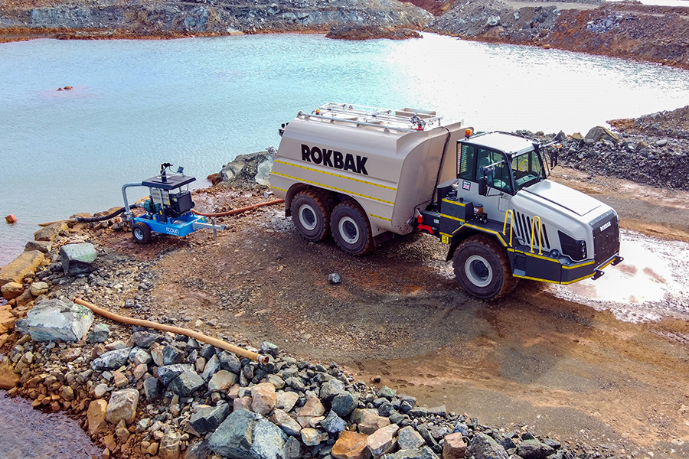

*Articulated haulers are built for more than quarries, proving their strength in surprising applications.*

ADTs such as the [Rokbak](http://www.rokbak.com/) [RA30](http://www.rokbak.com/ra30) and [RA40](http://www.rokbak.com/ra40) are built for off-road performance, steep grades and tough terrain. Haulers such as these feature regularly across projects you’d expect them – and some where you wouldn’t! Here's a look at six unique, and perhaps unexpected, ways articulated haulers are working harder and smarter – beyond the pit.

1. **Water trucks: taming dust and fighting fires**

One of the most versatile adaptations of ADTs is the [articulated water truck](https://www.rokbak.com/news/strong-and-stable-ra30-trucks-carry-the-weight-at-new-caledonian-mine/). These haulers can be used for dust suppression, site cleaning and even emergency firefighting. Equipped with water tanks and pumps, ADTs can perform on the tough terrain where traditional fire trucks may struggle. Units are able to transport water, assist in earth moving and prove a stable presence in unstable conditions. Recently, through a partnership with Hydex, Rokbak haulers have been transformed into mobile water distribution units, which you can read more about [here](https://www.rokbak.com/news/from-dirt-movers-to-dust-busters-rokbak-adts-power-new-water-truck-line/).

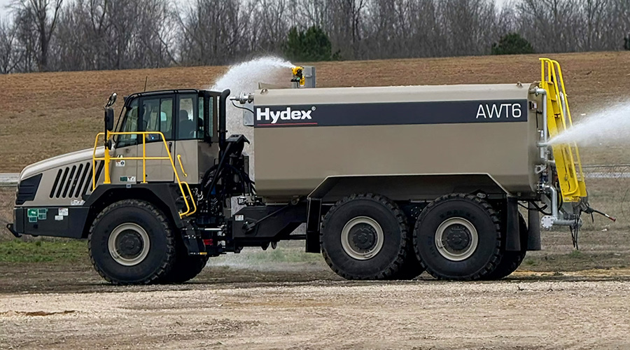

*Hydex has adapted robust Rokbak RA30 and RA40 articulated haulers into high-capacity water trucks to meet the growing demand for dust suppression.*

1. **Forestry trucks: clearing the way**

In the dense and often uneven landscapes of forest operations, haulers fitted with logging platforms have become forestry workhorses. Their ability to traverse slippery, muddy and steep terrain makes them ideal for hauling large quantities of logs to and from remote locations. ADTs with logging racks help maintain forestry productivity even in adverse weather conditions or undeveloped sites.

1. **Military logistics trucks: in the combat zone**

The robust engineering of articulated haulers makes them perfect for defence operations. Modified as military trucks, these vehicles can transport equipment, munitions or personnel across unpredictable terrain where conventional trucks would fail. Their high ground clearance and drivetrains are well-suited for rapid deployment, disaster response and logistical support in both combat zones and humanitarian missions.

1. **Drilling rigs: foundations for infrastructure**

Drilling and geotechnical projects can benefit from ADTs converted into mobile drilling platforms. When equipped with hydraulic drill arms and on-board compressors, these rigs can reach otherwise inaccessible sites – whether for mineral exploration, utility installation or foundation work. Their articulation and all-terrain capability mean operators can access tough areas without creating new access roads, minimising environmental impact.

1. **Waste disposal: keeping clean**

Articulated trucks can play an essential role in waste management, especially in landfills, recycling facilities, demolition sites and waste processing plants. Nearly every landfill uses one or more ADTs for tasks like cell development, hauling soil and building haul roads. Designed for rough terrain, slopes and soft or wet ground, these trucks are ideal for the challenging conditions often found in such environments. Their versatility and durability make them a key asset in efficiently transporting waste and debris across large-scale operations.

1. **Disaster relief and emergency response: haulers on hand**

Whether it’s a flood, landslide or wildfire aftermath, ADTs can be rapidly repurposed for emergency logistics. Their ability to transport heavy supplies, debris and water can contribute to post-disaster operations. The high articulation and ground clearance allow access to remote areas where other trucks cannot go, delivering aid or clearing paths for emergency services.

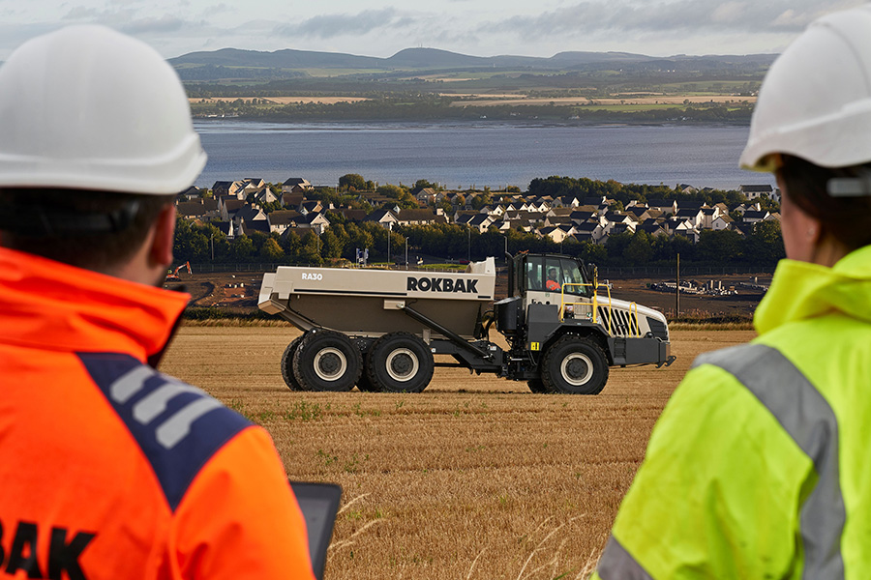

*Rokbak articulated haulers are robust and reliable.*

Moulded in Motherwell, Scotland, Rokbak’s ADTs are built to be more than dump trucks. The RA30 and RA40 platforms serve as rugged, reliable foundations for industry-specific solutions and can help redefine what’s possible on – and off – the road.

**For more information, please visit the** [**Rokbak**](https://www.rokbak.com/about-us/) **website.**

**Ends.**

**CONTACT:**

**Jacqueline Reid** **Jack Porter**

Rokbak SE10

Tel: int +44 (0) 7736117456 Tel: int +44 (0) 7794578947

Email: press@rokbak.com Email: [jack.porter@se10.com](mailto:jack.porter@se10.com)

**ABOUT ROKBAK**

Rokbak is a manufacturer of off-highway articulated haulers that are used in mining, quarrying, and construction applications around the world. A member of the Volvo Group and headquartered in Motherwell, Scotland, UK, Rokbak has two models of articulated haulers, with payloads ranging from 28 to 38 tonnes (30.9 to 41.9 US tons).

[rokbak.com](http://www.rokbak.com)