**PRESS RELEASE**

February 2025

**Scottish engineering, Irish grit: Rokbak RA30 joins Loughran Rock’s quarry fleet**

**Loughran Rock’s new RA30 articulated hauler from Scottish manufacturer Rokbak is driving efficiency and productivity at the company’s quarry in Northern Ireland, supporting its continued business success.**

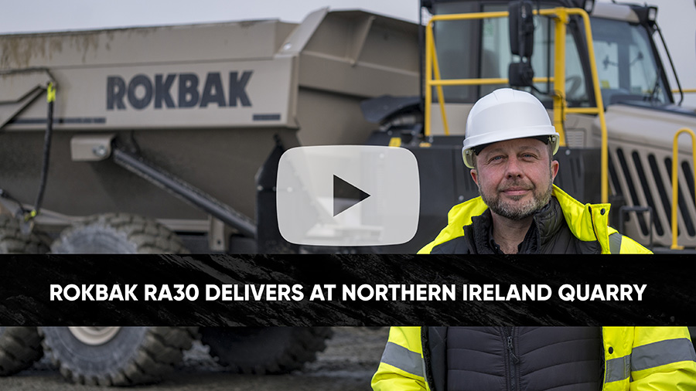

*Click the above image to watch the video.*

Just twelve miles lie between Scotland and Northern Ireland at their nearest points across the Irish Sea, and now the two Gaelic nations’ close relationship can write another chapter thanks to Scottish articulated hauler manufacturer [Rokbak](https://www.rokbak.com/about-us/).

[Sleator Plant](https://www.sleatorplant.co.uk/), a leading supplier of construction machinery in Northern Ireland, has delivered a Motherwell-manufactured Rokbak [RA30](https://www.rokbak.com/ra30/) articulated dump truck (ADT) to [Loughran Rock Industries,](https://www.loughranrock.com/) a renowned family-owned quarrying and aggregates business based in County Armagh.

Since its establishment in 1985, Loughran Rock has invested in high-quality equipment that supports its extensive operations, which range from concrete production to stone supply for major infrastructure projects. Now the company is benefitting from the durability, efficiency and mobility of a Rokbak RA30 articulated hauler on site in Cláidigh Bheag, approximately an hour south-west of Belfast.

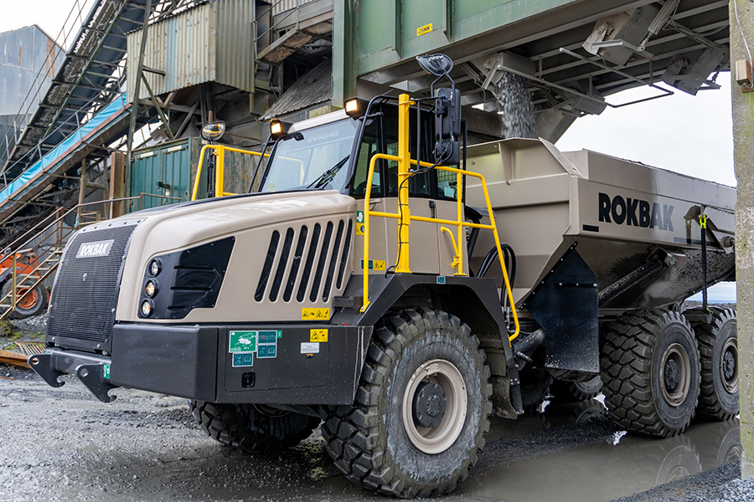

*Loughran Rock Industries' Rokbak RA30 articulated dump truck.*

“We’ve not only reinforced our quarry operations with the addition of the Rokbak truck, but we believe we’ve also strengthened our position as a trusted supplier in the region,” says Colin Loughran, a Loughran Rock quarry manager.

**Moving on up**

Loughran Rock produces between 450,000 and half a million tonnes of aggregate every year. Its production supplies local contractors, housing developments and farmers, so high uptime from all its equipment is a necessity. As the authorised dealer of Rokbak trucks in Northern Ireland, Sleator Plant reassured Loughran Rock Industries of the RA30’s durability and performance, built to the highest standards in Scotland, and its efficiency in moving earth and materials across challenging sites.

“We proposed the RA30 to Loughran Rock for the truck’s agility, dependability, independent suspension for operator comfort and the ability to carry lighter products efficiently,” explains Aaron McCaul, a general manager at Sleator Plant.

The RA30 articulated hauler has a 28 tonne (30.9 US ton) maximum payload and a 17.5m3 (22.9yd3) heaped capacity. The fully independent suspension and wheel movement is provided by a double wishbone design. This is coupled with 4 x hydraulic dampers/coil over springs.

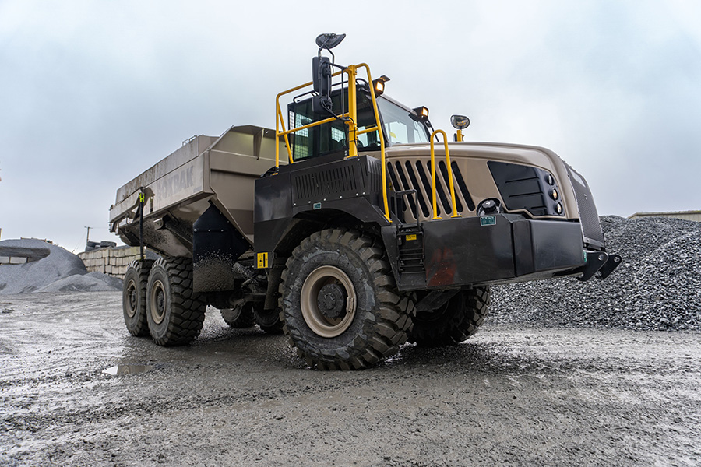

*The truck is used to transport materials to the main crusher and fill up concrete bins.*

The truck arrived at Loughran Rock at the end of 2024 and is predominantly utilised to transport stone, sand, rock-fill and muckshift across the quarry to the main crusher and fill up concrete bins for lorries and block machines. The hauler was customised with body side extensions to maximise load capacity, enabling the transport of lighter materials while maintaining optimal efficiency. With its superior manoeuvrability, stability on stockpiles and efficient cycle times, the RA30 has quickly proven to be a valuable asset.

“We needed an agile and robust machine to navigate the site’s challenging conditions,” says Colin. “In contrast to rigid trucks, we find the articulated hauler much more efficient on the stockpiles.”

**Rock solid relationships**

Rokbak has a commitment to long-term partnerships with its emphasis on the importance of aftermarket services. With a dedicated engineering team and a local presence, Sleator Plant ensures prompt maintenance and parts availability to its customers in the region. This latest addition to Loughran Rock Industries’ fleet underlines a confidence in Sleator Plant and Rokbak machinery and relationship and was purchased with one year’s full warranty and three years, 5,000 hours power train warranty.

“As specialists in the supply of machinery to the construction and material rehandling sectors, with a focus on innovation, quality engineering and value for money, we thought the RA30 was the perfect choice for Loughran Rock’s needs, offering reliability, durability and the backing of our responsive aftersales support,” adds Aaron.

Since arriving at Loughran Rock, the RA30 has received positive feedback from its Loughran Rock operator Cathal Devlin, with praise for its visibility, driver comfort and fuel efficiency.

“Visibility is important on any site, especially a big quarry such as this,” says Cathal. “The rear vision camera and monitor and heated mirrors makes my life a whole lot easier when I’m reversing into tight spots, and when you’re driving around quarries, you need comfort. I’ve been operating for three years now with trucks of all sizes, and the Rokbak truck is definitely the comfiest machine I’ve driven to date.

“I’ve also been impressed by its fuel efficiency. With our previous truck we had to fill it up approximately every two days. With the Rokbak it’s now every three to four.”

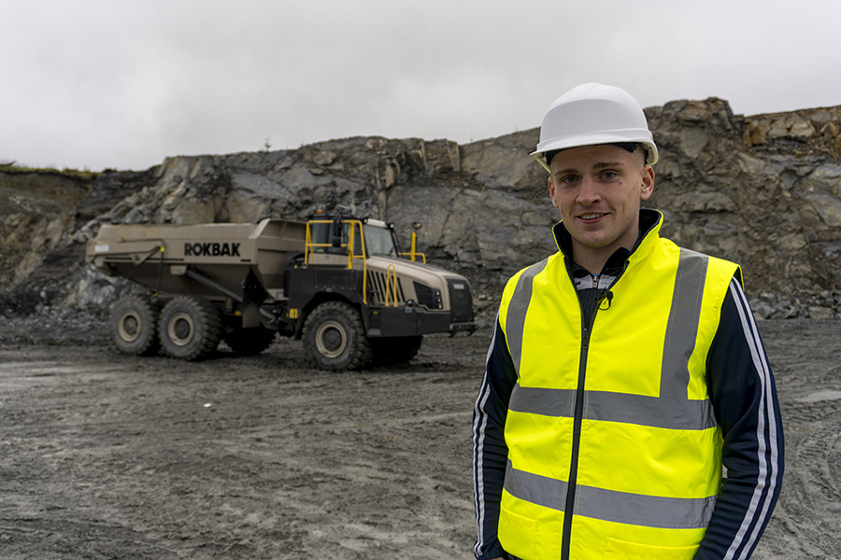

*Loughran Rock operator Cathal Devlin in front of the RA30.*

Rokbak’s fuel-efficient drivetrains deliver powerful performance and meet worldwide emission standards with low cost of operation and low environmental impact. The high-performance drivetrain has responsive, usable power with adaptive shifting for low fuel consumption and operating costs.

Another efficiency aspect of the Rokbak design is easy service access, making the RA30 a quick and simple to maintain with ground level test points, electric-lift hoods and tilting cabs, enabling high uptime and productivity.

“As quarry manager, I know first-hand that you have to get the right plant for the job,” adds Colin. “You want something reliable – the less downtime the better.

“The RA30 has been nothing but reliable, with minimal maintenance requirements and prompt support from Sleator Plant when needed. It’s well made and it’s a good, sturdy machine. In the future, I would not hesitate to use Rokbak again.”

**For more information about Rokbak, please** [**visit the Rokbak website**](https://www.rokbak.com/about-us/)**.**

**For more information about Loughran Rock Industries, please** [**visit the Loughran Rock Industries website**](https://www.loughranrock.com/)**.**

**For more information about Sleator Plant, please** [**visit the Sleator Plant website**](https://www.sleatorplant.co.uk/)**.**

**Ends.**

**CONTACT:**

**Jacqueline Reid** **Jack Porter**

Rokbak SE10

Tel: int +44 (0) 7736117456 Tel: int +44 (0) 7794578947

Email: press@rokbak.com Email: [jack.porter@se10.com](mailto:jack.porter@se10.com)

**ABOUT ROKBAK**

Rokbak is a manufacturer of off-highway articulated haulers that are used in mining, quarrying, and construction applications around the world. A member of the Volvo Group and headquartered in Motherwell, Scotland, UK, Rokbak has two models of articulated haulers, with payloads ranging from 28 to 38 tonnes (30.9 to 41.9 US tons).

[rokbak.com](http://www.rokbak.com)